WEST LONDON WASTE AUTHORITY
Report of the Projects Director | 2nd December 2022
Projects 23/24 Introduction
SUMMARY
This report provides an introduction on the proposed WLWA programmes for 2023/24.
- Cost pressures across the Boroughs and Authority require significant change and investment
- The three WLWA programmes are designed to deliver savings and greater financial stability
- The greatest element of cost in the waste system is the divertible material in the residual waste

RECOMMENDATION(S)

- Approve the initiation of the WLWA 23/24 Programmes before April 23
- The Authority is asked to note the information within this report

- Introduction
This report is an introduction to the main programme areas proposed for the 2023/24 budget with a recommendation for the governance of the programme.
The Authority and the Boroughs are facing significant challenges in the next three years through increasing inflation impacting contracts and operations as well as legislative change across the waste system. These impacts affect both collection and disposal elements of the services and such require and partnership approach to mitigate risk and take opportunities.
The programmes introduced in this report are designed to create the financial stability required for the Boroughs and the Authority by addressing the greatest cost to the service, the composition and volume of residual waste.
The aim of the programmes is to create benefits through efficiency and waste reduction whilst building a robust data to measure current performance and model future changes required to meet the 2030 waste and carbon targets of the Authority and Boroughs.

- WLWA 23/24 Programme
WLWA are proposing to deliver change and investment across the waste system to generate savings and service efficiency. The change programmes have been developed and costed in the budgets for the next three years commencing in April 2023.
The three programmes are;
- Digital Twin
- Social Value and Reuse
- Communications
  - Digital Twin
The WLWA smart cities policy objective is that by 2030 west London service provision for residual waste, recyclables and materials must be efficient, dynamic, fully utilised and generating income where possible. Residents will be fully aware of their local services and engaging with them correctly because they’re easy to use, they can identify the materials for separating and they understand the benefit to them and others of participating. This project will begin the journey to a carbon neutral west London where waste is treated as a valuable resource.
The objective of this project is to create a digital twin of on the ground waste and recycling services and achieve rapid decarbonisation and cost savings for Boroughs through data led efficiency savings. The Project will be evaluated over 3 years and will identify future annual costs and savings in the next steps.
Output: Online digital twin of on the ground services, real time dynamic links to measure the current performance of these services, model efficiencies and / or model future efficiencies or challenges such as the impact of EPR, DRS, Consistency regulations, population growth, changes in recycling behaviour, collection systems for hard to recycle items etc.
Links: This project is intrinsically linked with the Communications Project which will create data and scenarios for the modelling of public engagement with the services. The Net Zero Planner (Social Value and Reuse Project) is needed to support this project part time.
  - Social Value and Reuse
The WLWA HRRC policy objective is that residents shall receive an enhanced service through consistency of service with information about services offered at a resident’s nearest site clear and transparent, active travel should be encouraged for wherever it can be achieved, we must enhance the re-use element of HRRCs and the sites should add value to the local community. Understanding that each site has different constraints, to be acknowledged and considered when developing collective infrastructure and development decisions shall actively consider the wider sustainability agenda.
The objective of this project is to increase separation of materials, innovate new handling and storage methods to retain the value of the item not just the material it is made from. The project will deliver immediate changes to existing infrastructure and measure the social and financial value of circular economy projects. We will test our ability to invest directly into Borough sites not owned by WLWA and measure the co-benefits of efficiencies. The project will test service resilience to change.
Output: Procured support bringing online sales experience and offtake capacity from the waste sector. Increased capacity for every HRRC site to do more separation of materials. Signage in every HRRC to promote the increased separation of specific materials eg the Fixing Factory laptop. Establishing circular economy hubs at Abbey Road, Victoria Road and Harrow School for the north of the area (and TBC Space Waye and Stirling Road for the south of the area).
Links: This project is intrinsically linked with the Communications Project which will capture data to better understand the impact of these new services on public engagement with the climate action and understanding of waste as a resource. This project will use HRRC and bulky waste collections booking system data to inform decision making and innovation. The Digital Twin project will inform future infrastructure development for phase 2 of this project.
  - Communications
The objective of this project is to test citizen knowledge and attitudes to recycling services. It will create content to provide more and better information on some of the more complex issues and test knowledge and attitudes again at the end. Recycling, reuse, social value and waste data will also be used to evaluate the project.
Food waste recycling is the service that most citizens don’t use (Appendix 1). Persuading every household to recycle food waste will reduce waste, reduce cost, increase recycling and contribute to global and UK decarbonisation. It will result in cost savings for citizens, Boroughs and WLWA. Cost savings for WLWA and Boroughs means more money available to invest in other recycling services. We want to normalise food waste recycling and ban food waste from the bin.
Plastics recycling is extremely complex, some plastics are technically and economically easy to recycle, some are very difficult. Most plastics are made from fossil oil which is environmentally damaging. The producers of plastic packaging want to make more and have us recycle more plastic, the public attitude appears to be for less plastic.
Textile recycling is low volume but high value of both cost and carbon. Textiles are rapidly becoming as complex as plastics with 100s of grades of different material, from eg cotton, wool, mixed fibres to types of plastic. We want to prevent textiles from going in the bin.
Electricals and batteries - Large electrical items are predominantly recycled if taken back in store or to HWRCs but a) small electrical items find their way into the bins and b) we need to preserve the value of the product through reuse. Electricals and batteries in the bin cause fires and are environmentally damaging.
Output: Baseline citizen knowledge and understanding of complex recycling systems and the links with climate change. Create and deliver content designed to significantly increase citizen knowledge and attitudes. Baseline again and review the waste and recycling statistics and outcome of the social value and reuse project.
Links: This project will test public awareness of the Re London food waste campaign, Borough recycling messages, the social value and reuse project at the beginning and end. It will build upon the burgeoning Joint Communications Board and develop strong cross Borough messages. The project will provide data and information to inform the digital twin project. It relies on using some MI specialists time employed on the Digital Twin project.
- WLWA six project areas
WLWA have already established six key areas (figure below) in the development of the five year programme. The three programmes detailed in this report cross over some project areas but mainly fall with the Smart Cities (Digital Twin), HRRC transformation (HRRC and Social Value) and Data management/Food waste (Joint Communications).
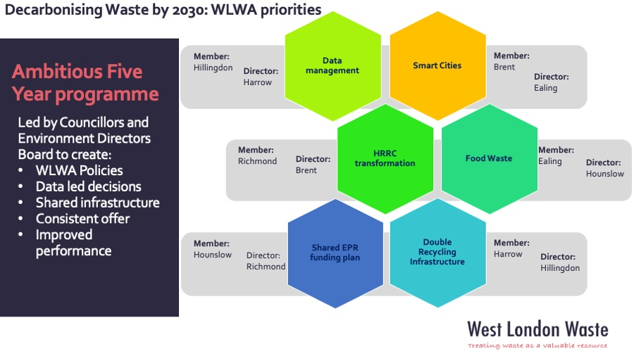
The outputs from the three programmes during the next three years will feed into the Data management project and inform the design of the required additional recycling infrastructure. The Digital Twin work will create the basis for the modelling and impacts of the EPR funding plan as additional information is forthcoming on the detail of the legislative changes.
The breadth of the programmes and the whole system approach to deliver and benefits requires significant partnership working with the Boroughs in a similar manner to the food waste investment. This creates complexities, as experienced in the food investment, in the delivery and measurement of the benefits and returns, the majority of which fall directly to the Boroughs.
Based on the lessons learnt from the food waste investment we are discussing the preferred governance structure for the reporting and measurement of the programmes with the Environment Directors. The Projects Director will come back to the Authority with a recommendation on governance structure.
- Risk
New legislation and details regarding EPR, DRS and the Environment Bill, that will impact on all waste services are expected soon. Officers are seeking to identify potential impacts are factor these in during the development of all projects.
This includes significant work on data and collections systems to help inform on whole system impacts of future legislative such as consistency of collection. Due to the nature of the programmes Boroughs will be required to provide regular detailed data on the associated benefits to capture the whole system impacts of the investments.
- Financial Implications
WLWA have set out the investments and returns in the proposed budget. These will be measured against programme specific Key Performance Indicators (returns, carbon, social value etc.) and reported regularly through the proposed governance structure.
The proposed investment has been fully funded through the excess revenue generated from the WLWA PPP contract. The cost over the next three years is c.£2,815k with current estimated Borough and WLWA returns of £5,400k over the term.
WLWA officers are working on initiating the programmes during the current 22/23 financial year but there will be no impact to current budgets with all costs starting in Apr 23.
WLWA projects are designed to test and change the whole system to deliver benefits financially, environmentally and socially. Due to the whole system approach, there are aspects of the delivery and returns that require significant partnership working and multiple stakeholder changes, as such absolute returns are modelled, risk assessed and tracked but cannot be guaranteed.
- Staffing Implications – To deliver the programmes introduced in this report the Projects and Circular Economy team will need to be restructured. This will be designed and completed by March to start the delivery of the programmes in line with the budget from Apr 23.
- Health and Safety Implications – The programmes introduced above require development of operational sites and as such will have implications for Health and Safety. Many of the operational site changes have already been implemented and tested at Abbey Road and the WLWA Operations and Projects Teams will support the delivery of the Borough teams.
Additional Health and Safety training is being planned for the team to ensure all members are informed to a standard to help raise awareness on site visits.
- Legal Implications - none
- Joint Waste Management Strategy
The projects mentioned in this report are intrinsically linked to the Authority’s Joint Waste Management Strategy and Business Plan.
The West London Environment Directors have established four priority areas over the next two years as detailed in the WLWA Business Plan paper and summarised below.
- Bringing the Community with us (Behaviour change)
- Sustainable Decision Making across West London
- Climate adaptation and Decarbonisation
- Dealing with Financial challenges whilst delivering on Climate Change

The Environment Directors key priorities align with the WLWA Budget programme with investment and delivery across three areas. The Environment Directors priorities align as follows;

 | Behaviour Change | Sustainable Decision Making | Climate adaptation and Decarbonisation | Dealing with Financial Challenges
Smart Cities |  | Digital twin | Fleet resource optimisation/planning | Efficiency Rerouting
Social Value and Reuse | Circular Economy | Social Value | HRRC investment | Waste reduction
Joint Communications | Resident engagement |  |  | Waste reduction

Contact Officers | Peter Tilston, Projects Director 07796 271 713  petertilston@westlondonwaste.gov.uk  Motoko Doolan, Net Zero Carbon Manager 07917 075 876  motokodoolan@westlondonwaste.gov.uk  Sarah Ellis, Strategic Development Lead 07584 631 710  sarahellis@westlondonwaste.gov.uk

